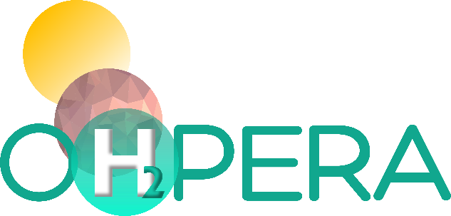

Optimised Halide Perovskite nanocrystalline based PhotoElectrolyser for clean, Robust, efficient and decentrAlised H₂ production

Responsible Research and Innovation in OHPERA
Report & Conclusions of the first session

Lead beneficiary: LOMARTOV (LOM)
Author(s): Alba Lafarga, Yamina Guidoum

DATE: 28/11/2023

Abstract: This document is a product of WP5, Task 5.4 Social Sustainability: Responsible Research & innovation, technology acceptance & awareness. It presents the results of the first Responsible Research and Innovation workshop (RRI) which took part with the members of the OHPERA consortium. The objective of the workshop was to gain an understanding of the RRI concept and methodology and their importance for achieving social acceptance and awareness. It was also meant to build a common ground for a shared vision of RRI in the consortium.
The conclusions and recommendations of this report will form the first building block for further actions to embed RRI in the OHPERA project and design guidelines for social awareness and acceptance (Deliverable 5.3).

PROJECT DATA
Project Acronym | OHPERA
Project Title | Optimised Halide Perovskite nanocrystalline based Electrolyser for clean, robust, efficient and decentralised Production of H₂
Project number | 101071010
Call identifier | HORIZON-EIC-2021-PATHFINDERCHALLENGES-01
Topic identifier | HORIZON-EIC-2021-PATHFINDERCHALLENGES-01-04
Type of action | HORIZON EIC Grants
Project Duration | 42 months
Coordinator | UNIVERSITAT JAUME I DE CASTELLON (UJI), Spain, Sixto Gimenez Julia sjulia@fca.uji.es
Website | www.ohpera.eu
DELIVERABLE DOCUMENT SHEET
Deliverable No. | D5.3
Deliverable title | Guidelines for social awareness and acceptance
Description | Compilation of OHPERA communication guidelines adapted to the different relevant stakeholders
WP No. | WP5 - Sustainability guidance and validation
Related task | Task 5.4 Social Sustainability: Responsible research & innovation, technology acceptance & awareness
Lead Beneficiary | LOM
Author(s) | Alba Lafarga, Yamina Guidoum
Contributor(s)
Type | R
Dissemination Level | Sensitive - SEN
Language | English – GB
Due date | 28/11/2023 | Submission date | 28/11/2023

DOCUMENT HISTORY
DATE | VERSION | AUTHOR | COMMENT
28/11/2023 | V 1.0 | LOM – Alba Lafarga, Yamina Guidoum | First complete version

Acknowledgement



This project has received funding from the European Union’s Horizon Europe research and innovation programme under grant agreement No 101071010.
This project is framed within the activities of the European Innovation Council under the call HORIZON-EIC-2021-PATHFINDERCHALLENGES-01-04 - Novel routes to green H₂ production.

Disclaimer

Views and opinions expressed are however those of the author(s) only and do not necessarily reflect those of the European Union. Neither the European Union nor the granting authority can be held responsible for them.
All intellectual property rights are owned by OHPERA consortium members and are protected by the applicable laws. Reproduction is not authorised without prior written agreement.
The commercial use of any information contained in this document may require a license from the owner of that information.
For citation purposes: “Alba Lafarga Aguilar, Yamina Guidoum, Responsible Research and Innovation in OHPERA - Report & Conclusions of the first session, OHPERA Project number 101071010, 2023, 76 pages, LOMARTOV”.

ABBREVIATIONS AND ACRONYMS
ABBREVIATIONS AND ACRONYMS
BGU | University of Ben-Gurion | MS | Microsoft Teams
D | Deliverable | NGOs | Non-governmental Organisations
EC | European Commission | No | Number
eChem | eChemicles | Q&A | Questions and Answers
EIC | European Innovation Council | R&D | Research and Development
EU | European Union | R&I | Research and Innovation
GA | Grant Agreement | RRI | Responsible Research and Innovation
HZB | Helmholt Zentrum Berlin | SEN | Sensitive
ICIQ | Fundació Privada Institut Català d'Investigació Quimica | SRL | Societal Readiness Level
LCA | Life Cycle Assessment | UJI | University of Jaume I Castellón
LOM | LOMARTOV | WP | Work Package

TABLE OF CONTENTS
ABBREVIATIONS AND ACRONYMS 4
1. What is Responsible Research and Innovation? 6
2. Applying RRI in OHPERA 7
2.1 Structure of the RRI sessions 8
3. First Session: Anticipation and Reflexivity 8
4. Results of the first RRI Session 11
4.1 Assessing previous knowledge about RRI 11
4.2 Introducing the key dimensions of RRI and assessing their current status in OHPERA 11
4.3 Dimension 1: Ethics 12
4.4 Dimension 2: Public engagement 14
4.5 Dimension 3: Science education 15
4.6 Dimension 4: Open Access 15
4.7 Dimension 5: Gender dimension 15
4.8 Dimension 6: Governance 16
4.9 Prioritising the key dimensions and identifying ways to implementing them 16
5. Conclusions & Recommendations 18
6. References 19
Annex 1: Questions & Answers of the workshop - Extract from the Mentimeter 19

LIST OF TABLES
Table 1. Participants list – First RRI workshop 9

LIST OF FIGURES
Figure 1: RRI characteristics, dimensions, and stakeholders involved 7
Figure 2: A screenshot of the first OHPERA RRI workshop (online, MS 23/10/2023) 9
Figure 3: Concept note of the first OHPERA RRI workshop 10
Figure 4. Assessing previous knowledge and experience about RRI 11
Figure 5: Participants assessment of how RRI dimensions are currently reflected in OHPERA 12
Figure 6: Ethical considerations of the OHPERA project 13
Figure 7: How to solve the ethical issues identified by the OHPERA partners 14
Figure 8: Potential stakeholders identified by the OHPERA partners 14
Figure 9: Potential barriers to Open Access and how to overcome them 15
Figure 10: Key RRI dimensions supporting the SRL of the OHPERA technology 17
Figure 11: RRI vision stated in the OHPERA project (Word Cloud Art) 17

What is Responsible Research and Innovation?
Responsible Research and Innovation (RRI) is a methodological process that involves anticipating the possible consequences of Research and Innovation (R&I), discussing issues openly, and involving society in discussions about how science and technology can contribute to a better quality of life and human well-being. Ideally, new technological developments would fit from the start into societal values, needs, and expectations since the society is ultimately the final beneficiary and the one that needs to be motivated to adopt the innovation.
Since it requires implementation by process, the first RRI session is an initiation one that is meant to make the participants anticipate and reflect, without requiring them to prepare material in advance, but rather to share their current viewpoints and ideas. There are no correct answers, although what needs to be considered is the project view at the moment of the session, when the work is organized, and when the research activities are designed.
While R&I is more widely known, when we add "Responsible" a meaningful change emerges and requires a redefinition and a reflection. First, RRI is an iterative process, implying a pathway of continuous development until reaching the goal of creating public support and legitimacy for new innovations or research developments.
Most of the time, people tend to be resistant to new breakthroughs, due to the comfort and the fear of the unfamiliar and unknown. RRI is paving the way for future possibilities. The results of R&I in projects must benefit society in order to encourage them to embrace it, otherwise, it will become part of the scientific database. Moreover, the RRI process broadens the picture by involving all types of stakeholders: citizens and society, governments, industry, and other actors in its assessment.
The first “R” from RRI means “Responsible”, but also stands for sustainable, both for people and society nowadays, but equally for future generations and the environment. In other words, it implies co-creation, since it involves all categories of people and is a circular process that takes into account circular economy principles, as well as being itself a circular process.
Moreover, it provides an opportunity for everyone to be informed, involved, and to be able to contribute. In the end, the RRI method is an all-or-nothing process, which means that if we want to embed the first “R” in the RRI, then we must address all points.
The full RRI picture can be summarized in 3 layers:
- The 6 key dimensions: Ethics, Public engagement, Gender dimension, Science education, Open access, governance.
- Stakeholders: Research community, Business & Industry, Civil society, Policy makers, Education community.
- Values: Diverse and inclusive, Anticipative, and reflective, Responsive, and adaptive and Open and Transparent.
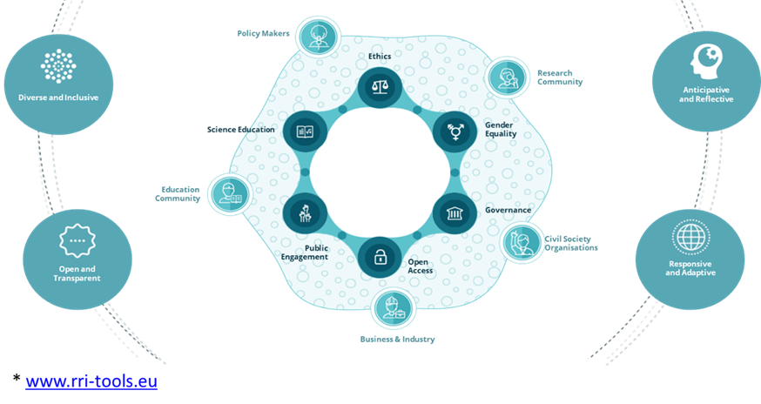
Figure 1: RRI characteristics, dimensions, and stakeholders involved

Applying RRI in OHPERA
The RRI process can be easily compared to Design Thinking, an approach that will inspire the methodological work. In the first steps, the participants gain understanding of the key RRI dimensions, the stakeholders, and the process in itself. This allows questioning pre-existing beliefs and the way we do things. It is a creative process and not a ready-made solution, in the sense that it is entirely dependent on what the participants will make of it. It is thus important that the participants gain ownership of the RRI process, to ensure project results will eventually be more ‘Responsible’.
The following steps consists in identifying actions for implementing RRI in the research project. Such actions may not change the course of the research in itself but could better prepare the results of the research for societal adoption, paving the way to a higher Societal Readiness Level (SRL). In the last step, it is crucial to review the entire process and identify any improvements that can be made.

2.1 Structure of the RRI sessions
The RRI process will be implemented through various sessions, in the form of workshops, as part of Task 5.4, work package (WP5) on Social Sustainability: Responsible Research and Innovation (RRI), technology acceptance & awareness.
The objective of this task is to identify and assess the main issues that can affect social acceptance and awareness of green hydrogen production in OHPERA as a novel technology. The sessions will allow an understanding of social expectations and needs regarding this technology so as to start building awareness around it. The outcomes of the sessions will feed into deliverable (D)5.3. Guidelines for social awareness and acceptance.
The RRI sessions will be structured using the model of the Societal Readiness Thinking Tool developed by the European Union (EU) funded NewHoRRIzon project and adapted to OHPERA’s specificities and needs. It mainly follows the four steps of the model:
- Anticipation: carefully examining both the intended and possible unintended consequences arising from research activities, including environmental, health-related, economic, and social impacts.
- Reflexivity: reflecting on the underlying motivations, assumptions, and commitments that drive research projects. It commits researchers to inquire and challenge the taken-for-granted assumptions that structure their work.
- Inclusion: involving relevant societal actors in research and innovation activities from an early stage, and ensuring continuous, open dialogue about desirable and undesirable outcomes throughout the project.
- Responsiveness: aligning research and innovation activities with the new perspectives, insights, and values emerging through anticipatory, reflexive, and inclusion-based RRI processes.
This document deals with the first and second steps, which were the subject of Session 1 of this process in the form of a workshop.

First Session: Anticipation and Reflexivity
The first workshop took place on Monday 23rd of October 2023 and was virtual (see Figure 2), using Microsoft Teams, MS. Nine participants took part, covering the entire OHPERA consortium, except the University of Ben-Gurion (BGU) who could not attend (see Table 1). LOMARTOV (LOM)’s representatives Alba Lafarga and Yamina Guidoum were the moderators of the workshop and thus did not take part in the votes and answers to the questions, to avoid bias. A set of qualitative questions were asked, and the answers were collected using Mentimeter.com, which allowed interaction through live votes and contributions as well as providing instantaneous graphic representations.
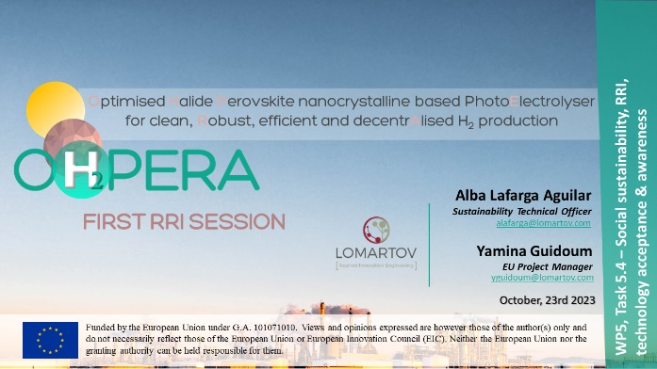 | 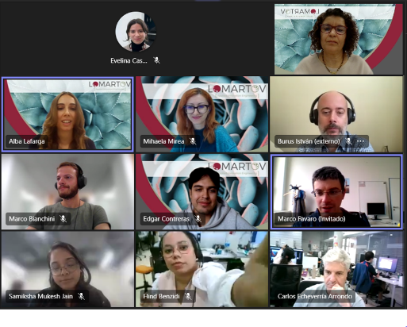
Figure 2: A screenshot of the first OHPERA RRI workshop (online, MS 23/10/2023)
Table 1. Participants list – First RRI workshop
No. | Name | Partner
1 | Samiksha Mukesh, Technical WP1 | UJI
2 | István Burus, Business Analyst and Project Manager, WP4 & WP6 | eChem
3 | Marco Favaro, R&D WP4 | HZB
4 | Hind Benzidi, R&D WP3 | ICIQ
5 | Carlos Echeverría, R&D WP3 | ICIQ
6 | Edgar Contreras, Technical WP5 | LOM
7 | Marco Bianchini, Technical WP5 | LOM
8 | Alba Lafarga, Project Officer WP6 | LOM
9 | Yamina Guidoum, Project Manager, WP6 | LOM
University of Jaume I Castellón (UJI), eChemicles (eChem), Helmholt Zentrum Berlin (HZB), Fundació Privada Institut Català d’Investigació Quimica (ICIQ), LOMARTOV (LOM)

Objectives:
- Gain an understanding of the RRI concept and methodology and their importance for achieving social acceptance and awareness.
- Build a common ground for a shared vision of RRI in the consortium.
- Identify opportunities for embedding RRI in the project’s research and scientific work.
Agenda:
- Part I (15 minutes) – General introduction to and overview of RRI concept and key dimensions, illustrated with practical examples.
- Part II (1:45 minutes) – Live and interactive Question & Answer on each key dimension of RRI, their prioritisation and ways forward for their implementation.
A concept note of the workshop was previously shared with the participants to explain the objectives and what to expect from it (see Figure 3).
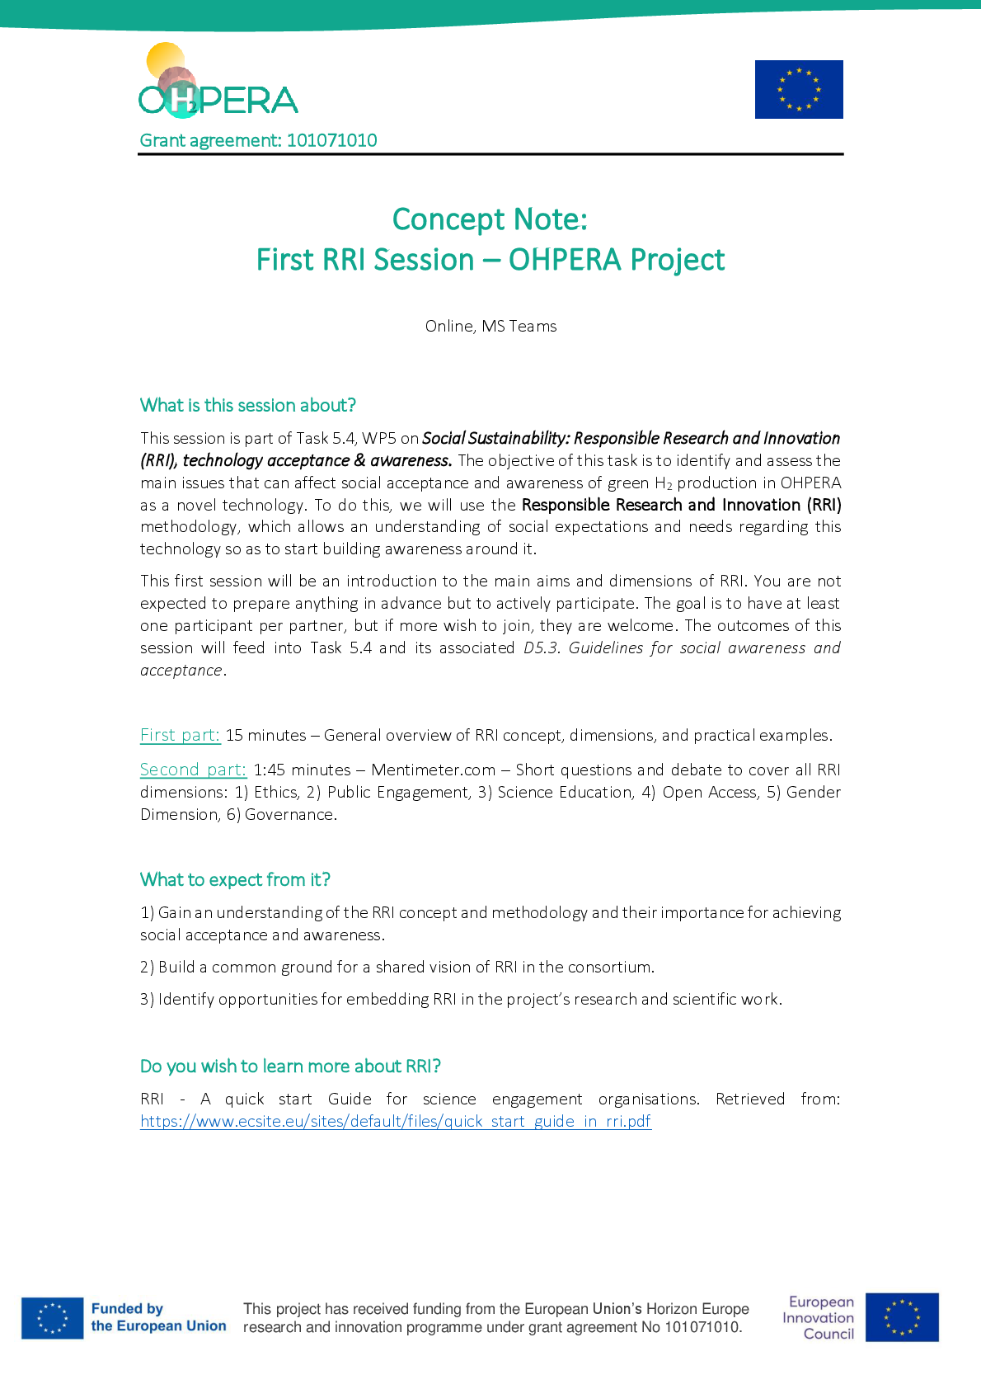
Figure 3: Concept note of the first OHPERA RRI workshop

Results of the first RRI Session

Assessing previous knowledge about RRI
The interactive part of the session started with general questions to assess partner´s previous knowledge and experience of RRI. The results show that most participants have not worked before with RRI principles in projects, while a few have heard about the methodology and how it was implemented in practice mentioning social acceptance and awareness issues, stakeholders’ interactions (i.e., surveys and interviews), social dimension in research processes, ethical approach in publishing. These results are represented in the Figure 4 below.

Figure 4. Assessing previous knowledge and experience about RRI

Introducing the key dimensions of RRI and assessing their current status in OHPERA
To start the reflective process, the moderators first made a presentation to introduce and explain the six key dimensions of RRI and their meaning, illustrated with practical examples. The six dimensions are Ethics, Public engagement, Science education, Open access, Gender and Governance.
After making sure these concepts were understood, the participants proceeded to vote about how much each dimension is currently reflected and taken into consideration in OHPERA, according to them. The voting results are represented in Figure 5 below.

Figure 5: Participants assessment of how RRI dimensions are currently reflected in OHPERA
Each one of the RRI dimensions are either positively seen or considered familiar for the partners. Open Access and Science education dimensions were appreciated by the participants as expected, since most have a research and academia profiles.
There is a need to dig deeper in Public engagement and Governance dimensions, particularly how to really engage public actors (i.e., policymakers, non-governmental organisations NGOs, public associations, etc.). Efforts need to be dedicated in communicating consistently and transparently when transferring the research and scientific results to the key stakeholders identified in the project.
Science education, Open Access and Ethics dimensions were easier to understand and identified as already reflected to some extent in the project, although work on them needs to continue throughout the project evolution and attention need to pay to those dimensions which require further actions.
OHPERA, as any HORIZON-funded project, already covers in the Grant Agreement preliminary proposals on how RRI is embedded in the project. However, the collaborative work undertaken through this workshop shows the importance and determination of the partners to support the implementation of RRI to ensure progress toward social acceptance and by extension a higher SRL level.

Dimension 1: Ethics
This dimension is focused on ensuring open, responsive, accessible, and transparent processes for highest ethical societal standards with research integrity, which in the end will support adequately responding to the fundamental rights and for societal challenges. In this dimension, participants discussed if the project was well-focused for both society and environment. The results on the ethical considerations are represented in the following Figure 6.
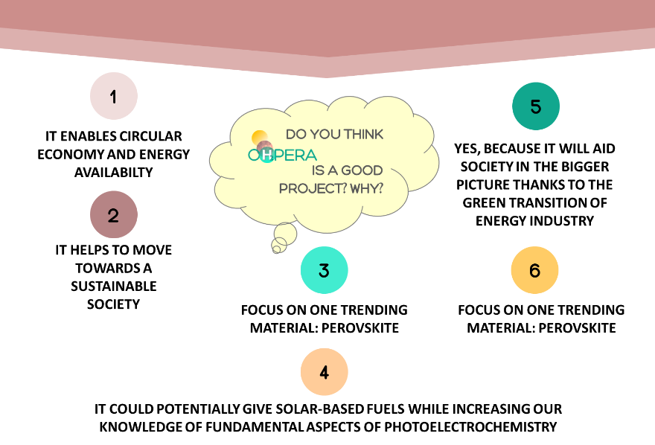
Figure 6: Ethical considerations of the OHPERA project
However, the OHPERA partners also noticed the potential ethical issues that the project could developed when aiming to reach the results and outcomes. For instance, the project consortium needs to take care of the efficient use of resources and waste management and tracking the purchase of materials and its suppliers during the technological developments and their associated costs. Also, these technological developments should be closely monitored at each stage to ensure there do not inadvertently contribute to the environment. Moreover, the life cycle assessment (LCA) must be implemented considering forward-looking impacts, while considering the recyclability of the technology in 20 years from now. Especially at this long-term some problems could arise from the material safety and the control of the end-of-life procedures, which could undermine society’s trust on science and research. To this end, the participants discussed about potential pathways to overcome these ethical issues, gathered in Figure 7. Of course, the participants mentioned that any potential ethical issue that appears throughout the OHPERA’s development should be pointed out to all the consortium and deal together with all the partners, and/or, supported by LOM and eChem (in charge of WP5) and reviewing the European Innovation Council (EIC) policies recommended.

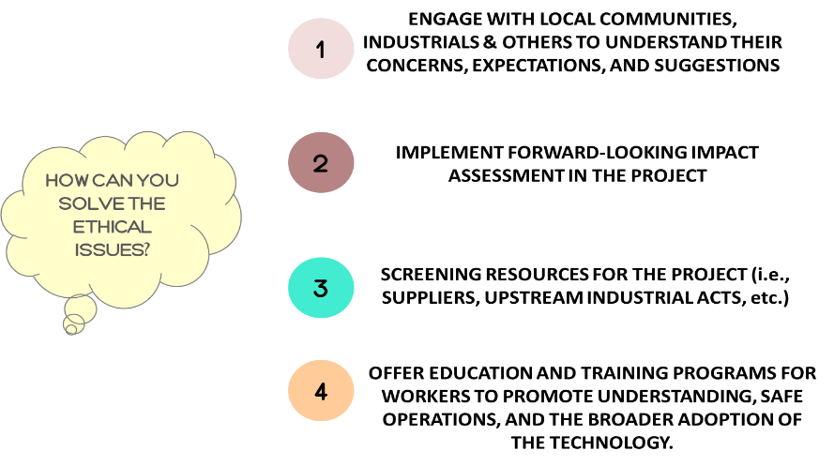
Figure 7: How to solve the ethical issues identified by the OHPERA partners

Dimension 2: Public engagement
Public engagement dimension intended to assess the involvement of all societal actors and key stakeholders such as researchers, innovators, industry, policymakers, civil society for joint and active participation in the R&I processes, supporting to co-define and co-construct this technological solutions, products, and services for better alignment with society’s values, needs and expectations. During this dimension, the OHPERA partners discussed about the potential stakeholders that must need to involve, and/or to work with to make sure the research project is aligned with the values, needs, and expectations of the society. The Figure 8 represents the potential stakeholders identified by the consortium.

Figure 8: Potential stakeholders identified by the OHPERA partners
In addition, the participants pointed out that we need to engage and connect with our stakeholders because their interests or perspectives, usually different from the scientifical and technological points of view, will support to complete the framework of the uptake and acceptance of the OHPERA technology. However, engaging with such a wide spectrum of actors, who can provide such different points of view and priorities, might complicate the OHPERA’s uptake. Nevertheless, the participants considered that to involve these people in the project and have benefits or influences from them could be done through:
- Social media campaigns;
- Forums;
- Conferences and workshops;
- and bringing more science to the media (i.e.., television, radio, etc.) and expand the outreach.
To conclude with this first RRI approach, the Public Engagement dimension will be further developed and evaluated through the next session, by an in-depth stakeholder analysis.

Dimension 3: Science education
This RRI dimension aims to communicate science in an understandable and engaging way to the general public, that in the end, will support the attractiveness of research and science and the knowledge to fully responsible join R&I processes. The OHPERA consortium expects to involve the public in the data collection and analysis processes. In this regard, the project’s know-how and skills expected to be communicated will be to increase the information about hydrogen generation from water, the use of novel nanomaterials, value of close loop solutions. The participants address that sharing all this OHPERA’s know-how could be done by:
- Tuition-free conferences;
- Online e-learning platforms;
- Mobile apps;
- and public events.
Finally, partners agree that same as the OHPERA’s results and know-how will be successful and shared, uncertainty in results will appear through the research process. This is a key issue that OHPERA consortium knows it must be communicated. In this first session they pointed out that uncertainty must be addressed openly and transparently, in the deliverables and all public reports. In this approach, the public will also understand how science and research work: uncertainty is an inherent part of the research when you are developing a technology solution.

Dimension 4: Open Access
Open Access is about collaboration, transparency, and accessibility of research. This approach aims to provide easily understood scientific advancements and results in open platforms. The OHPERA consortium discussed aspects on potential barriers that could happen throughout the open access process. These potential barriers identified and the actions to address them are gathered and represented in the following Figure 9.
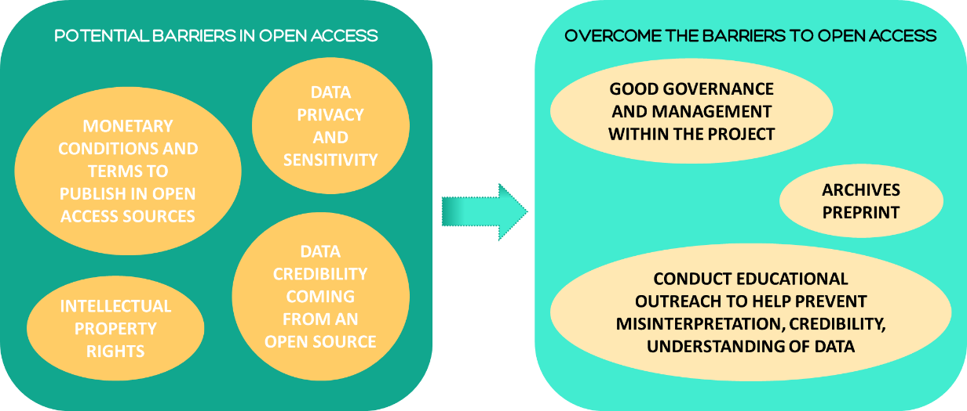
Figure 9: Potential barriers to Open Access and how to overcome them

Dimension 5: Gender dimension
Gender dimension is aimed at integrating all societal actors of all genders in research and innovation activities and results. This dimension must be considered, especially when scientific findings may affect women and men differently, to unlock the full potential of R&I. The OHPERA participants did not found difficulties on gender and equity, especially with the current the project results and work. They only pointed out that maybe job opportunities should be a key issue regarding technological and scientific, usually governed by men. Nevertheless, to make sure the mid and long-term OHPERA project impacts will be beneficial and positive for both men and women, they stated “to involve both genders in dissemination activities”, and still engaging this RRI dimension, since they did not consider it so far.

Dimension 6: Governance
The Governance dimension is about engaging collaboration with research and development (R&D) centres and policymakers into the research, as key actors who have the responsibility to prevent harmful or unethical scientific developments. The participants discussed about how the inputs from such stakeholders or other societal groups are included in the OHPERA’s research, concluding that such collaboration might be difficult at this point or do not exactly sure how they could be managed/implemented. Nevertheless, they already identified in this first session that the Governance dimension at least should be included and adapted in the OHPERA’s research developments by sustainability and exploitation activities and through surveys and questionnaires, and joint webinars.

Prioritising the key dimensions and identifying ways to implementing them
Having realized that most of the participants were either unaware of the RRI methodology or had heard occasionally about its dimensions prior to this RRI session, targeted questions were raised just after all dimensions were assessed. After all participants discussed about how the OHPERA project activities are aligned with societal needs and expectations, they voted among all the RRI dimensions considering which dimensions are going to help us better mature the SRL of the OHPERA technology (Figure 10). The OHPERA partners consider the Science education dimension as the key dimension to further deploy advances in the project responsibility commitment, closely followed by the Ethics and Public engagement dimensions. In addition, the participants provided ideas on how to successfully implement these most relevant RRI dimensions, according to the current project stage. They mentioned to establish more interaction between WPs, to increase the engagement with policymakers and schools, or other training academia, and to keep on working on the exploitation strategy to reach the right stakeholders in the future of the project. Nevertheless, there are three other key dimensions that as the least voted (i.e., Open Access, Governance, Gender Education) which must be further engaged and look out on how to potentiate the project resources to implement them at the current project stage and for mid- and/or long-term advances.

Figure 10: Key RRI dimensions supporting the SRL of the OHPERA technology
Next, the participants wrapped up the session by conducting a Word Cloud Art, an interactive feature included in Mentimeter.com which allows to map the most powerful keywords regarding an aspect discussed. In this regard, participants defined by a word their vision of the RRI methodology in the OHPERA project. The Word Cloud results are represented in the Figure 11, considering the RRI as a necessary, multi-stakeholder and transversal methodology to implement in the OHPERA project.
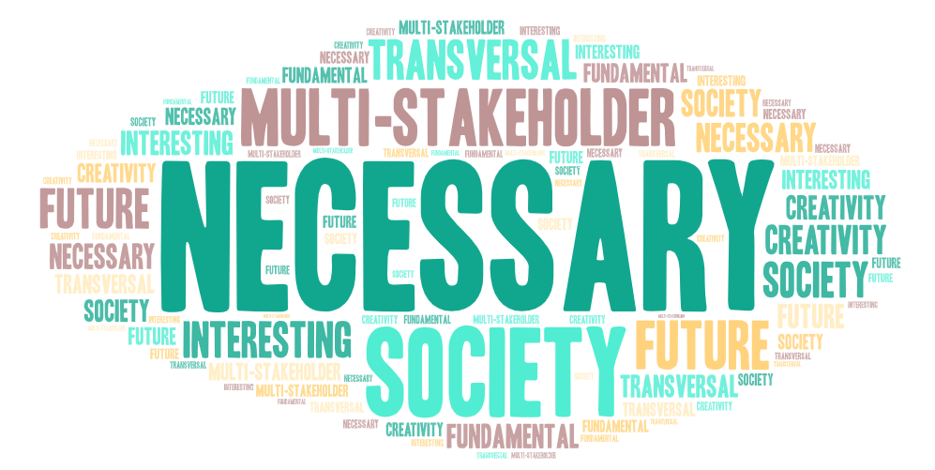
Figure 11: RRI vision stated in the OHPERA project (Word Cloud Art)

Conclusions & Recommendations
This report gathers the first RRI session conducted by the OHPERA project, driven by practical examples and Mentimeter.com to generate useful contributions and productive discussions to target the key aspects of this methodology and successfully achieving the main expectation of the session: to conduct a self-reflective exercise and setting the common understanding ground on this RRI methodology embedded in the project. Next, results from the session are gathered and evaluated, considering all details from each of the RRI dimensions, which allow to produce some conclusions and recommendations that will support further work dedicated to ensuring the triple sustainability of the OHPERA technology, especially to be reported by the upcoming D5.3 Guidelines for social awareness and acceptance. The conclusions and recommendations to consider by this first RRI session within the OHPERA project are:
- Consider potential ethical issues that the project could create in the mid and/or long-term (i.e., material safety and society’s trust in the technology). These ethical issues must be monitored by the entire consortium, supported by LOM and eChem (WP5), in line with the EIC recommended policies.
- Engage and connect with OHPERA’s stakeholders. Their opinions and recommendations are valuable for the uptake and acceptance of the technology.
- Include policymakers and other societal groups: keep them informed or even engage them in consultations regarding early adoption of the new solution.
- Ensure transparency and proper management of all research and scientific results: “uncertainty is an inherent part of our research”.
- Find measures and ideas for a better integration of Gender and Governance dimensions in the current stages of OHPERA’s implementation.
- Keep the focus on Science Education, Ethics, and Public engagement, these having been identified as a priority for maturing the social readiness level of OHPERA’s technology.

References
- Baker III, F. W., & Moukhliss, S. (2020). Concretising design thinking: A content analysis of systematic and extended literature reviews on design thinking and human‐centred design. Review of Education, 8(1), 305-333.
- Burget, Mirjam & Bardone, Emanuele & Pedaste, Margus. (2017). Definitions and Conceptual Dimensions of Responsible Research and Innovation: A Literature Review. Science and Engineering Ethics. 23. 10.1007/s11948-016-9782-1.
- Euroscientist, 15.11.2022, https://www.euroscientist.com/ethics/
- Malvina Artheau (Science Animation Midi-Pyrénées, France), Carlos Catalão (Ciência Viva-Pavillion of Knowledge, Portugal), Patrizia Famà (MUSE, Italy), Gonçalo Praça (Ciência Viva-Pavillion of Knowledge, Portugal), Antonina Khodzhaeva (Ecsite, Belgium), Sheena Laursen (Experimentarium, Denmark), Lucia Martinelli (MUSE, Italy), Giovanni Stijnen (NEMO Science Museum, the Netherlands), Andrea Troncoso (Ecsite, Belgium), Liina Vaaher (Science Centre AHHAA, Estonia), Marjoleine van der Meij (VU Amsterdam, the Netherlands), RRI- A quick start guide for science engagement organisations. https://www.ecsite.eu/sites/default/files/quick_start_guide_in_rri.pdf
- Mentimeter, 2023. Mentimeter Features [accessed: 24 October 2023]. https://www.mentimeter.com/features
- NUCLEUS project, 16.11.2022, http://www.nucleus-project.eu/
- RRI Tools, 15.11.2022, https://rri-tools.eu/
- RRI in Horizon Europe, 15.11.2022, https://rri-in-horizon-europe.net/
- RRI related topics, 16.11.2022, https://rriinhorizoneurope.files.wordpress.com/2020/12/rri-in-materials-research-era-net-nov-2020-1.pdf
- The turing way, 16.11.2022, https://the-turing-way.netlify.app/ethical-research/ethical-research.html
- Ulrike Felt, Maximilian Fochler & Lisa Sigl (2018) IMAGINE RRI. A card-based method for reflecting on responsibility in life science research, Journal of Responsible Innovation, 5:2, 201-224, DOI: 10.1080/23299460.2018.1457402

Annex 1: Questions & Answers of the workshop - Extract from the Mentimeter
This annex is generated by Mentimeter. It includes a compilation of the introduction to the six key dimensions of RRI that was presented at the workshop and of the Questions and Answers (Q&A) that took place, including some graphics.

R: Document, report; DEM: Demonstrator, pilot, prototype; DEC: Website, video etc., DATA: Data sets; DMP: Data management plan; ETHICS; SECURITY; Other: Software, technical diagram, algorithms, models etc.
PU: Public, fully open; SEN: Sensitive.
RRI - A quick start guide for science engagement organisations. Malvina Artheau (Science Animation Midi-Pyrénées, France), Carlos Catalão (Ciência Viva-Pavillion of Knowledge, Portugal), Patrizia Famà (MUSE, Italy), Gonçalo Praça (Ciência Viva-Pavillion of Knowledge, Portugal), Antonina Khodzhaeva (Ecsite, Belgium), Sheena Laursen (Experimentarium, Denmark), Lucia Martinelli (MUSE, Italy), Giovanni Stijnen (NEMO Science Museum, the Netherlands), Andrea Troncoso (Ecsite, Belgium), Liina Vaaher (Science Centre AHHAA, Estonia), Marjoleine van der Meij (VU Amsterdam, the Netherlands). Retrieved from: https://www.ecsite.eu/sites/default/files/quick_start_guide_in_rri.pdf
idem
Baker III, F. W., & Moukhliss, S. (2020). Concretising design thinking: A content analysis of systematic and extended literature reviews on design thinking and human‐centred design. Review of Education, 8(1), 305-333.
Denmark, I. F. (2019). Societal Readiness Levels (SRL) Defined According to Innovation Fund Denmark.
The NewHoRRIzon Project – An Experiment in Responsible Research and Innovation. https://newhorrizon.eu/
Mentimeter, 2023. Mentimeter Features [accessed: 24 October 2023]. https://www.mentimeter.com/features
Mentimeter, 2023. Mentimeter Features [accessed: 24 October 2023]. https://www.mentimeter.com/features
Mentimeter, 2023. Mentimeter Features [accessed: 24 October 2023]. https://www.mentimeter.com/features

