
Coastal Inundation Analyses with Marine Radar-Derived Wave Characteristics
M. Said PARLAK¹, Matteo POSTACCHINI¹, Maurizio BROCCHINI¹
¹ Università Politecnica delle Marche, Italy
m.s.parlak@staff.univpm.it
m.postacchini@staff.univpm.it
m.brocchini@staff.univpm.it
Abstract
Shore-fixed X-Band Marine Radar (XBR) collected data during a relatively energetic storm at our study site. We analyzed XBR images with Lightweight Image Assimilation Framework (LIMASSI) to retrieve wave characteristics. Comparison with field measurements showed that the LIMASSI reconstructed the sea state satisfactorily. These conditions were provided to a phase-resolving model, inundation analyses were conducted, and the results were compared with empirical methods. Consequently, the empirical methods could not capture the peak runup location and alongshore variability.
- Method
Relatively energetic storm hit Senigallia, a maritime city in Italy, at the beginning of April 2023, and it was recorded by a buoy and XBR. We developed a framework (LIMASSI) which utilizes Radon Transformation and Continuous Wavelet Transformation to process XBR recordings. Eventually, spatiotemporal characteristics of wave propagation were evaluated such as refraction, significant wave height, period and wavenumbers. These characteristics were provided to FUNWAVE (FW), phase-resolving Boussinesq model (Shi et al., 2012), to conduct coastal inundation analyses and compare the results with simple empirical models that summarized in Table 1.
Table 1. Empirical formulations to predict the maximum runup, $R_{2}$.
Proposed by | Code | Parameters
Holman, 1986 | H86 | beach slope, significant wave height. peak wavelength
Stockdon et al., 2006 | S06 | beach slope, significant wave height. peak wavelength
Vousdoukas, 2014 | V14 | beach slope, significant wave height. peak wavelength
Atkinson et al., 2017 | A17 | beach slope, significant wave height. peak wavelength
Power et al., 2019 | P19 | beach slope, significant wave height. peak wavelength, hydraulic roughness length
- Results
The performance of LIMASSI on the prediction of wave characteristics was evaluated by deriving statistical parameters: correlation coefficient ($r_{cc}$), coefficient of determination ($r^{2}$), and root mean square error ($RMSE$) by comparing with MEDA observations, which is a multipurpose station at our study site (Table 2).
Table 2. The summary of statistical measurements on the performance of LIMASSI.
Parameter | $$r_{cc}$$ | $$r^{2}$$ | $$RMSE$$
significant wave height, $H_{s}$ | 0.89 | 0.79 | 0.21 m
peak period, $T_{p}$ | 0.90 | 0.54 | 0.54 s

Since LIMASSI reconstructed the sea state satisfactorily, the most intense event ($H_{s}$=2.03 m, $T_{p}$=7.4 s) was chosen to force FW model. The maximum swash length reached 27 m after an hour-long simulation and resulted in 0.86 m maximum wave runup (Fig. 1, A). S06 gave constant runup due to small Iribarren number and underestimated it significantly. P19 overestimated runup along the shoreline. The remaining models gave close results. Yet, the maximum runup location, the maximum runup value and the alongshore variation could not be captured accurately by these models (Fig. 1, B).
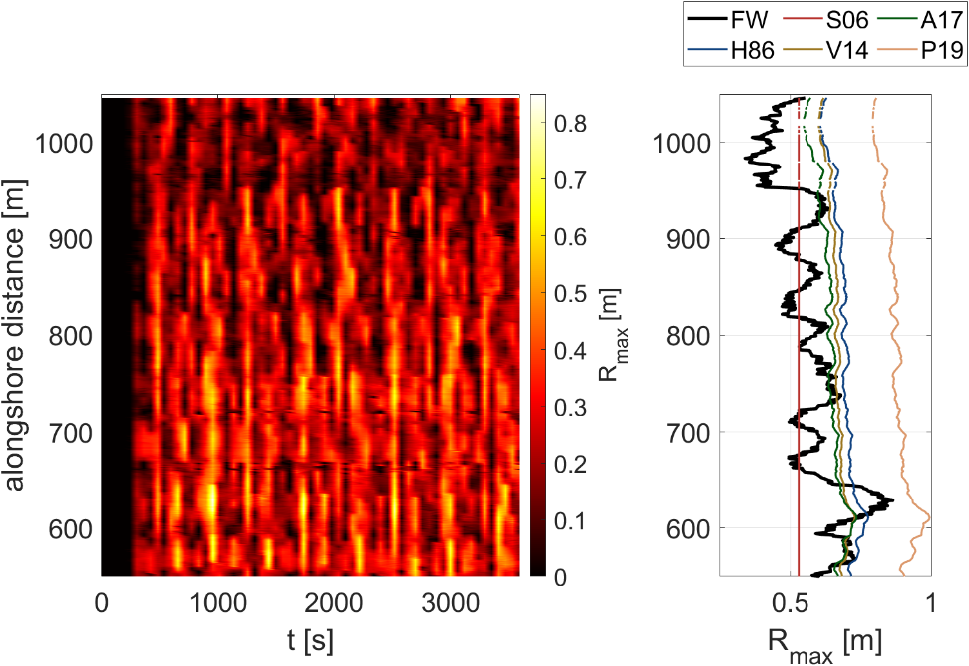
(B)
(A)
Fig. 1. A: Heatmap of spatiotemporal variation of wave runup. B: Comparison of maximum wave runup with the empirical models that summarized in Table 1.
- Ongoing Works
We focused on the better understanding of inundation dynamics under different wave conditions, especially when there is a cross-sea state, and enhancing the capabilities of LIMASSI to be used with alternative remote sensor data. By incorporating video monitoring system, swash and surf zone dynamics will be better resolved. Eventually, LIMASSI can be used to investigate the hydro-morphodynamic processes in a more robust way and at different sites.
Acknowledgements
This project has received funding from the European Union’s (EU) Horizon Europe Framework Programme (HORIZON) under Grant Agreement No 101072443 as a MSCA Doctoral Network (HORIZON-MSCA-2021-DN-01) of SEDIMARE.
References
Atkinson, A. L., Power, H. E., Moura, T., Hammond, T., Callaghan, D. P., & Baldock, T. E. (2017). Assessment of runup predictions by empirical models on non-truncated beaches on the south-east Australian coast. Coastal Engineering, 119, 15-31.
Holman, R. A. (1986). Extreme value statistics for wave run-up on a natural beach. Coastal Engineering, 9(6), 527-544.
Shi, F., Kirby, J. T., Tehranirad, B., Harris, J. C., & Grilli, S. (2011). FUNWAVE-TVD fully nonlinear Boussinesq wave model with TVD solver documentation and user’s manual. Center Appl. Coastal Res., Univ. Delaware, Newark, DE, USA, Res. Rep. No CACR-11-04, 2(1).
Power, H. E., Gharabaghi, B., Bonakdari, H., Robertson, B., Atkinson, A. L., & Baldock, T. E. (2019). Prediction of wave runup on beaches using Gene-Expression Programming and empirical relationships. Coastal Engineering, 144, 47-61.
Stockdon, H. F., Holman, R. A., Howd, P. A., & Sallenger Jr, A. H. (2006). Empirical parameterization of setup, swash, and runup. Coastal engineering, 53(7), 573-588.
Vousdoukas, M. I. (2014). Observations of wave run-up and groundwater seepage line motions on a reflective-to-intermediate, meso-tidal beach. Marine Geology, 350, 52-70.

